How to Create and Remove Window Password

Article Source:
http://recoverlostpassword.com/article/remove-windows-password.html

Many users do not set a Windows password when logging on; it is really a big security concern. Without Windows Password, anyone in your home or office can access to your computer fully and unrestrictedly. Creating Windows password is extremely important, but the chances are you forgot Windows Password one day, what should you do? You have to remove Windows password.

To offer you full-scale help, I would like to share how to create and remove Windows password.

Part I: How to Create Windows Password?
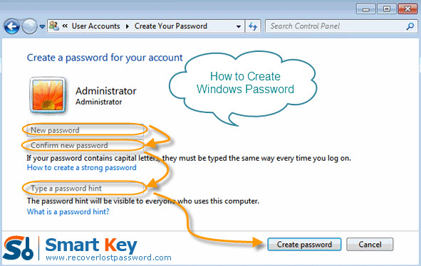
Here I take Windows XP for example:
- Click on “Start” -> “Control Panel”->”User Accounts”->”Create a Password”.
- Enter the password twice you would like to use, and make sure typed the passwords correctly.
- Click ”Create Password” button to confirm your new password.
- The next screen asks “Do you want to make your files and folders private”? If other user accounts will be setup on this PC and you'd like to keep your personal files private from those users, click on “Yes”, Make Private button.
- You can now close the User Accounts window and the Control Panel window. The new Windows password has been created.

Part II: How to Remove Windows Password?
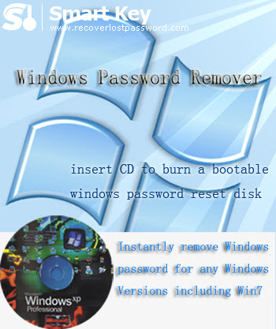
Windows Password Remover is by far the best utility to remove Windows password when you forgot it. It is easy to setup and use, making it the appropriate Windows password cracker for even the most novice of computer users.

Then follow the easy steps to remove Windows password.

Difficulty: Quite easy.
Time: Several minutes.
Things you need: An accessible computer, the computer you require password for, CD.

Step 1: Insert a blank CD into the accessible computer, and launch Windows Password Remover.
Step 2: Choose the recovery mode as your requirement. And tick “CD/DVD” and specify your device.

Note: For local account password reset, you should choose any version of Windows Password Remover.
But for domain administrator password reset, you have to choose Windows Password Remover Enterprise Version.

Step 3: Click “Burn” to begin bootable CD creation.
Step 4: Insert this CD to the computer you can’t access to and boot it from CD. You will enter the interface of Windows Password Cracker under Win PE.
Step 5: Choose the Windows installation to be processed. If you choose to reset local account password before, select the account you want to reset password. If you choose to reset domain administrator password, directly type the new password.
Step 6: Click “reset” and then hit “Yes” & “OK” in the next indicator.
Step 7: You need to reboot your PC to finish removing Windows password.

